OLIVER T’S MARKET

To Order: Stop In, or Call: (810) 695-6550, Fax: (810) 695-9140

Email: oliverts.store@gmail.com
1553 HILL RD, GRAND BLANC, MI 48439

CATERING TO GO

****Please Allow Minimum of 72 Hours’ Notice ****

****Half Trays Serve 8-12, Full Trays 16-20 ****

1553 E Hill Rd, Grand Blanc, MI 48439, phone (810) 695-6550, fax (810) 695-9735, web oliverts.com
Oliver T’s Market
Grand Blanc Shopping at its FINEST!

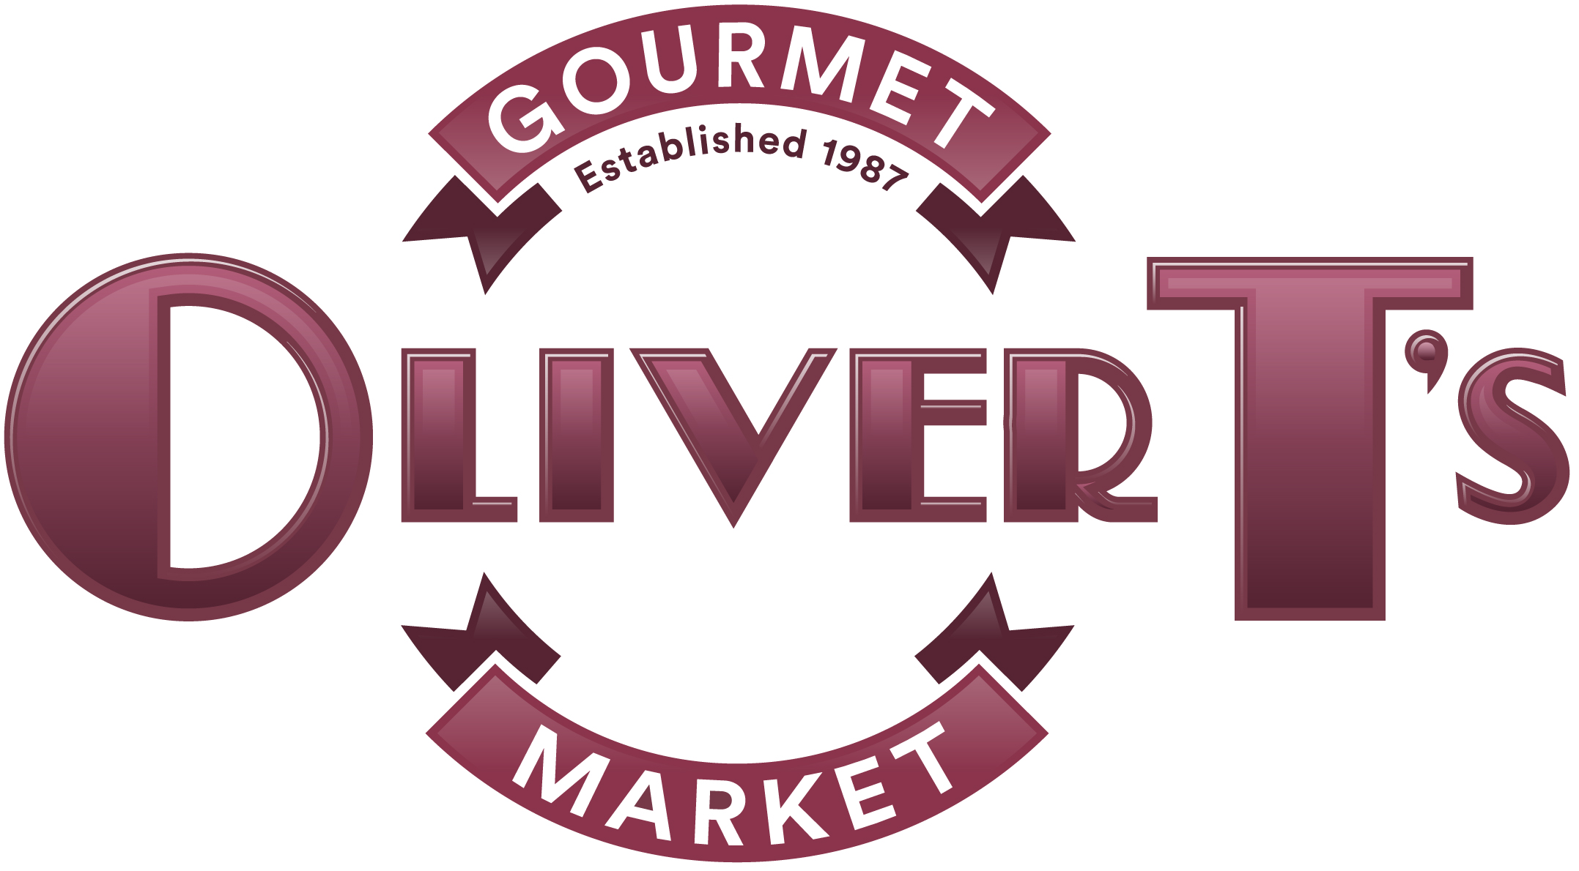

CHICKEN

Tray Half Tray/Half

Breaded All-White Meat Chicken Strips $100 $53 8lbs/4lbs
Choice of: Italian Marinara, Lemon-Lime w/Lemon Dill Sauce, Cajun w/Mustard Sauce, or Thai w/Coconut Peanut Sauce.
Buttermilk Fried Chicken $100 $53 10lbs/5lbs
Equal mix of breast, thighs, and drumsticks. Add 15% for custom mixes.
Baked Chicken $100 $53 10lbs/5lbs
Equal mix of breast, thighs, and drumsticks. Add 15% for custom mixes.
BBQ Chicken $100 $53 10lbs/5lbs
Equal mix of breast, thighs, and drumsticks. Add 15% for custom mixes.

Chicken Wings $95 $50 100 pc/50 pc
Choice of: Ranch, Marinara, Buffalo, or Teriyaki.

Pecan Crusted Chicken Breasts $150 $80 10lbs/5lbs

Lemon Pepper Chicken Breast $150 $80 8lbs/4lbs

Chicken Piccata w/Lemons & Capers $150 $80 10lbs/5lbs

Chicken Marsala $150 $80 10lbs/5lbs
With caramelized onion, mushrooms & sweet marsala wine sauce

Coconut Chicken Breasts $150 $80 10lbs/5lbs
With Mango Chutney add $9.00

Pesto Chicken $150 $80 10lbs/5lbs
Grilled Breast stuffed with basil pesto, topped with tomato relish and lemon basil sauce.

Chicken Parmesan w/Mozz. & Tomato Sauce $150 $80 10lbs/5lbs

Grilled Chicken Kabobs w/Vegetables $9.00 each, minimum 10

Chicken Pot Pie 5” individual pies $8.00 each, minimum 10
Chicken Wellington (in full puff pastry) $12 each, minimum 10
Stuffed Chicken Breasts $12 each, Minimum 10
Choice of: Broccoli & Cheddar, Fresh Basil, Garlic & Mozzarella, Cordon Bleu

TURKEY

Tray Half Tray/Half

Sliced Roast Turkey Breast $150 $80 10lbs/5lbs
Turkey Gravy $9.00 quart
BEEF/PORK

Tray Half Tray/Half

Old Fashioned Beef Meat Loaf $95 $50 10lbs/5lbs
Sliced or Whole, with Gravy

Beef Stroganoff with Egg Noodles $180 $95 14lbs/7lbs

Prime Rib of Beef $275 $140 10lbs/5lbs

Grilled Beef Tenderloin $375 $200 10lbs/5lbs
Choice of: Horse Radish or Dijon Sauce

Beef Wellington (in puff pastry) $23 pc, min 10, (72 hour notice required)

Grilled Steak Kabobs $11.00 each, min 10

Roasted Pork Loin $100 $55 10lbs/5lbs

Barbequed Pulled Pork $100 $55 10lbs/5lbs

Kielbasa & Sauerkraut w/Apples $100 $55 10lbs/5lbs

Italian Sausage $125 $65 10lbs/5lbs
With peppers, onions, and tomato sauce

Giant Mozzarella Stuffed Meatballs $5.00 each, min 10
With marinara

Italian Marinara Meatballs $120 $65 100 pc/50 pc

Barbequed Meatballs $120 $65 100 pc/50 pc

Swedish Meatballs $120 $65 100 pc/50 pc

Ground Beef Stuffed Cabbage Rolls $95 - 20 pc

PASTA/ITALIAN

Tray Half Tray/Half

Bolognese Lasagna $150 $80 14lbs/7lbs
A delicious meat lasagna with creamy bechamel topping

Vegetable Three-Cheese Lasagna $140 $75 14lbs/7lbs

Rigatoni w/Meat Sauce $95 $50 10lbs/5lbs

Rigatoni w/Tomato Sauce & Parmesan $85 $45 10lbs/5lbs

Simple Angel Hair or Bow Tie Pasta $55 $30 6lbs/3lbs
With lemon, garlic & olive oil. Great with Chicken Entrees!

Bow-Tie Pasta Alfredo $85 $45 10lbs/5lbs

Bow-Tie Pasta Alfredo w/Chicken Breasts $160 $85 14lbs/7lbs
Pasta Alfredo Primavera $125 $65 12lbs/6lbs

Chicken Piccata $160 $85 14bs/7lbs
Grilled Chicken Breast over pasta with garlic,
lemon, olive oil, parmesan and capers.

Corkscrew Pasta with Sausage Cream Sauce $110 $60 10lbs/5lbs

Corkscrew Pasta with Artichokes & Red Peppers

in Pesto Cream Sauce $110 $60 10lbs/5lbs

Penne Pasta w/Roasted Vegetables, Olive Oil

& Fresh Herbs $110 $60 10lbs/5lbs

Three-Cheese Gourmet Mac & Cheese $110 $60 10lbs/5lbs

Eggplant Parmesan $110 $60 10lbs/5lbs

SEAFOOD

Tray Half Tray/Half

Shrimp Linguine in Pesto Cream Sauce $220 $115 10lbs/5lbs
Approximately 5 shrimp per person

Grilled Salmon $240 $125 10lbs/5lbs

Choice of: Lemon Dill, Teriyaki or Creamy Horseradish

Pecan Crusted Salmon $240 $125 10lbs/5lbs

Cold Smoked Salmon $150 $80
serves 15-20 7-10
Garnished with diced red onions, tomatoes, lemons, capers, and fresh dill sauce, with whole wheat baguette slices.

SIDE DISHES

Tray Half Tray/Half

Vegetable and Onion Rice Pilaf $60 $35 8lbs/4lbs

Lemon Dill Rice w/Green Onions and Butter $60 $35 8lbs/4lbs

Orange-Cranberry Rice Pilaf (great hot or cold) $100 $55 8lbs/4lbs

Spanish Rice $60 $35 10lbs/5lbs

Real Mashed Potatoes (Garlic or Butter) $75 $40 10lbs/5lbs

Roasted Red Skin Potatoes $75 $40 10lbs/5lbs

Au Gratin Potatoes $100 $55 10lbs/5lbs

Twice Baked Potatoes $5.00 each, minimum 10
With cheddar, bacon, sour cream & chives.

Savory Sage Dressing $75 $40 10lbs/5lbs

Roasted Garden Vegetables $90 $50 8lbs/4lbs

New Orleans Corn with Bell Pepper $40 $25 6lbs/3lbs

Classic Baked Beans $40 $25 8lbs/4lbs
With mustard, onions and brown sugar
SIDE DISHES CONTINUED

Tray Half Tray/Half

Green Beans w/ Parmesan or Lemon Garlic Butter $75 $40 8lbs/4lbs

Green Beans Amandine or w/Tomato & Olive Oil $75 $40 8lbs/4lbs

Roasted Asparagus, Red Peppers, Onions & Garlic $75 $40 8lbs/4lbs
In Olive Oil

Slice Carrots w/Brown Sugar & Ginger Glaze $75 $40 7lbs/4lbs

Steamed Broccoli and Cauliflower $75 $40 8lbs/4lbs
With choice of: lemon butter or cheddar sauce

Broccoli Rice Casserole $75 $40 8lbs/4lbs

Crunchy Sweet Potato Praline Casserole $110 $60 10lbs/5lbs

Sweet Potatoes w/Dried Cranberries & Pecans $110 $60 10lbs/5lbs

SPECIALTY
Vegetarian Stir Fry (Gluten Free) $160 $85

Quiche (9 inch Quiches serve 6 – 8 people) $25/EA

Spinach & Feta *Lorraine *Ham & Broccoli *Turkey & Broccoli
- Ham & Asparagus *Mediterranean Tomato & Feta
Enchiladas (Beef or Chicken or Vegetarian) $160 $85
Vegetarian Stuffed Peppers w/tomato sauce $8.00 each, min 12
Grilled Veggie Kabobs $8.00 each, min 10
Jumbo Shrimp Tray w/cocktail sauce
24 pc tray $75
36 pc tray $105
50 pc tray $150
75 pc tray $225
GOURMET SALADS

****Please Allow Minimum of 24 Hours’ Notice ****

Salad Tray Half

Fresh Fruit Salad $95 $50

Classic Caesar w/house-made dressing $60 $35

Grilled Chicken Caesar $95 $50

Chef’s Salad $95 $50

with lettuce, ham, turkey, swiss, broccoli, carrots, cucumber, egg, ranch dressing

Oliver’s Garden Toss $60 $35
With gourmet lettuces and julienne vegetables

Premium Garden Toss $75 $40
With vegetables, red onion $ shredded cheddar

Greek Salad $95 $50
With feta, tomatoes, onions, beets, peppers, etc.

Antipasto $95 $50
With ham, salami, provolone, onions, peppers, etc.

Roman Salad $95 $50
With romaine, white beans, artichokes, cherry tomatoes, roasted red pepper, shaved parmesan & red wine vinaigrette.

Ultimate Cobb $110 $60
With romaine, smoked turkey, bleu cheese, bacon, egg, avocado, green onions, tomatoes & mustard vinaigrette.

Michigan Salad $95 $50
With mixed lettuces, feta, black beans, dried cherries & walnuts.

Chinatown Salad $95 $50
with mandarin oranges, almonds, chow mien noodles, baby corn, pea pods, peppers, dried cherries & onions.

Spinach $75 $40
With egg, red onions & hot bacon dressing
GOURMET SALADS CONTINUED

****Please Allow Minimum of 24 Hours’ Notice ****

Salad Tray Half

Strawberry Pecan $95 $50
With spinach, fresh strawberries & spiced pecans

Sweet Blue $95 $50
With lettuce, blue cheese, dried cranberries, candied pecans & poppy seed dressing

Maurice Salad $110 $60
With ham, turkey, swiss, olives, sweet pickles, and famous J.L. Hudson dressing.
** ADD GRILLED CHICKEN BREAST TO ANY SALAD FOR $12.50 LB.

PARTY TRAYS

Vegetable Tray (Small is $60 and Serves 15 – 20)
(Medium is $90 and Serves 25 - 30)
(Large is $120 and Serves 35 - 40)
Assorted Vegetables with both spinach & dill dips.

Fruit Tray (Small is $75 and Serves 15 – 20)
(Medium is $95 and Serves 25 - 30)
(Large is $125 and Serves 35 - 40)
Bite Size seasonal fruits with raspberry cream cheese dip or orange yogurt dressing

Fruit & Cheese Tray (Small is $80 and Serves 15 – 20)
(Medium is $105 and Serves 25 - 30)
(Large is $145 and Serves 35 - 40)
A colorful combination of our fruit and cheese trays

Middle Eastern Platter ($125 and Serves 10 – 15)
A beautiful presentation of Hummus, Tabbouleh, Spinach Triangles, Vegetarian Stuffed Grape Leaves & Silver Dollar Pitas. PLEASE ALLOW 2 DAYS NOTICE!

PARTY TRAYS

Gourmet Antipasto Platter ($140 and Serves 10 – 15)
A striking display featuring: Fresh Mozzarella, Tomato & Basil Tuscan Torta Dip (Feta Cheese, Sun-Dried Tomatoes, Pesto & Pine Nuts), Marinated Artichokes, Prosciutto & Cappicola Roasted Red Peppers, Mixed Olives & Two Baguettes. PLEASE ALLOW 2 DAYS NOTICE!

Gourmet Meat & Cheese
Features Boar’s Head Turkey, Polish Ham, Deluxe Ham & Roast Beef, Hoffman’s Hard Salami, Swiss, Smokey Cheddar, Provolone cheeses, Bread, Mayo, Mustard, and Tomatoes.

(Small is $85 and Serves 5-8)
(Medium is $125 and Serves 10-12)
(Large is $165 and Serves 15-18)

European Cheese Platter (Small is $95 and Serves 6 – 10)
(Large is $150 and Serves 12 - 16)
Fresh Mozzarella Slices, Brie & Boursin Cheeses, Greek Feta & Calamata Olive Spread, Goat Cheese Log, Lemon Ricotta Dip, Grapes & Assorted Crackers & Crustinis.

Cheese Tray (Small is $65 and Serves 10 – 15)
(Medium is $95 and Serves 18 - 25)
(Large is $120 and Serves 28 - 35)
Smoked Cheddar, Dilled Havarti, Colby & Swiss, arranged around choice of Cheese Ball with assorted crackers, Cheese Ball (Cream Cheese, Ham, Cheddar and Green Onion).

Nibbler Tray (Small is $85 and Serves 12 – 15)

(Large is $165 and Serves 25 - 30)
Delicious Cubes of Hard Salami, Ham, Swiss, Colby, Provolone & Smoked Cheddar with Green and Black Olives, Crackers.

PARTY TRAYS CONTINUED

Roll-up Platter ($95 and Serves 10 – 15)

Buttery Baguette & Lemon Ricotta Platter ($60 and Serves 10 – 15)

Fruit Skewers Platter ($90 for 50 skewers)

Fruit Pizza ($75 and Serves 15-20)

Prepayment is required for all catering orders.

